

**Vision Document**

***Problem Description:***

In the dynamic landscape of property leasing, landlords and property managers often need help with significant challenges, leading to operational inefficiencies and diminished tenant satisfaction.

The primary pain points include:

* A need for centralized information.
* Communication gaps with tenants.
* Bottlenecks in handling maintenance requests.

These issues hinder the smooth functioning of property management and compromise the overall leasing experience for both landlords and tenants.

***System Capabilities:***

* Create Account (Tenant/Landlord)
* Log In/Out
* Reset Password
* My Properties (Landlord)
  + - Lists all the properties owned
    - Provides tenant information
* Add properties (Landlord)
  + - Add new properties/vacancies
* View properties
* View tenants (Property list view)
  + - View Tenant information based on the property
* My tenants (landlord page)
  + - Find details about your tenants (demographics)
    - Signed Lease Agreements
    - Payment History
    - Edit Accounts
    - Send tenants reminders
* · Create requests (landlord)
  + - Send reminders for pending documents
    - Send request rent payment requests
* · Create requests (tenant)
  + - Submit Maintenance Request
    - Submit Appointments to speak with Landlord
* · Maintenance work orders (landlord)
  + - Work Order Report (Filter/Search enabled)
* · Account page (tenant)
  + - View Lease Agreement
    - View Reminders
    - Post on the community board
    - Online Payment Options for rent or bills
* Account page (landlord)
  + - Finances breakdown dashboard
      * Rental Report (Filter Rent paid, Overdue Rent, Pending Payments)
      * Expense Reports (Filter/Search enabled)
      * Deposits Reports (Filter/Search enabled)
* · Community reminders (tenant)
  + - Scheduled Pool Maintenance
    - Scheduled Grounds Keeping
    - Bake Sales or Fundraising Announcements
* · Bill payment reminders (tenant)
  + - Set Reminders to pay rent or utility bills
* · Online payment option (tenant)
  + - Link account to pay rent or utility bills
* · Maintenance reminders (tenant)
  + - Scheduled maintenance visits for work orders submitted
    - Handyman repairs

***Business Benefits:***

**1. Increased Efficiency:** SmartLease significantly improves operational efficiency for landlords and property managers by centralizing information and automating communication processes. Tasks that once suffered from delays and miscommunication now operate seamlessly, saving time and resources.

**2. Enhanced Tenant Satisfaction:** The streamlined communication channels and prompt resolution of maintenance issues contribute to a positive tenant experience. Happy tenants are more likely to renew leases, recommend properties, and foster a positive reputation for landlords.

**3. Data-Driven Decision Making:** SmartLease empowers landlords with valuable insights through its centralized database. Informed decision-making becomes a reality as property details, tenant histories, and maintenance trends are readily available, enabling strategic planning and proactive management.

**Summary:**

In conclusion, SmartLease is not merely a leasing app; it is a comprehensive solution that revolutionizes the leasing experience by tackling the root causes of common industry challenges. SmartLease sets a new standard for property management in the digital age through centralized information, robust communication, and efficient maintenance processes.

**Brief Use Case Descriptions Table**

|  |  |
| --- | --- |
| **Use Case** | **Brief use case description** |
| Create account (both) | Landlord/tenant can create an account, and the system creates an account for the specific user. |
| Login landlord/tenant account (both) | Landlord/tenant can log into an existing account, and the system will retrieve login information and link it to the landlord’s specific account. |
| Reset Password | Landlord/tenant can reset their password, then the system will send the user an email that will allow them to reset the password. |
| Look at properties (landlord) | Landlords can look at current properties they are managing, and the system shows clickable properties with a picture, name of the property, number of tenants, and income for the month. |
| Add property (landlord) | Landlord can add properties by entering the property name, image, and address; then the system retrieves the information and adds them to the my property page |
| Add apartments (landlord) | Landlord can add apartments by entering the apartment name, number of bedrooms, and number of bathrooms; the systems retrieves the information and adds an apartment to the specific property |
| Add tenants (landlord) | Landlords can add tenants to specific apartments by adding the name, occupation, age, gender, phone number, email, their rent contribution, signed lease, and their start date. System will then retrieve all of this data and create a tenant profile, as well as tenant data for the specific apartment |
| Send reminders (landlord) | Landlords can send reminders to either the entire property, entire apartment room, or to each specific tenant. System will see the reminder, and will populate a reminder on the tenant’s dashboard and reminder pages. |
| Request Rent (landlord) | Landlords can request rent from each apartment or each tenant. The system will send that request to the specific apartment or tenant's dashboard. |
| View all tenant information (landlord) | Landlords can view all tenants they are managing under the My Tenants Page. The system will show the tenant's name, place of residence, and apartment information. |
| View profile (both) | Landlord/tenant can view the tenant profile. The system will show what was inputted from adding the tenant, like the occupation, age, gender, etc. This can be edited and the system will update this information. |
| View lease (both) | Landlord/tenant can view the tenant’s lease, start date, and expiration date. The system collects this information from adding the tenant and displays it on the tenant’s profile. |
| View payment history (both) | Landlord/tenant can view their payment history in the tenant’s profile. The system allows scrolling to look for past invoices, as well as the dates and amount paid. |
| Edit Tenant Information (both) | Landlord and tenant can edit the tenant's profile. The system will retrieve the new information and update the profile once submitted. |
| Edit Tenant Property (landlord) | Landlords can edit tenant’s property information like the apartment and property they are staying at. System will collect this information and update all sections of the apartment, properties, and tenant information. |
| Delete tenant (landlord) | Landlords can delete tenants when necessary. The system will delete all tenant information, as well as the property and apartment they are staying at. |
| View maintenance requests (landlord) | Landlord can view all tenant requests for maintenance. The system will allow them to search for certain work orders. |
| Pay bills (tenant) | Tenants can pay bills by entering in their credit card information, and the system will collect their payment information and charge them automatically. |
| View upcoming reminders (tenant) | Tenants can view all of their upcoming reminders. System will display upcoming reminders, along with the times for some and clickable elements for others. Dashboard system will allow tenants to view a calendar option. |
| View to do reminders and apartment maintenance (tenant) | Tenants can view all their required tasks, and the system will make the task disappear and be marked as complete when the tenant marks it as complete. Tenants can also view all scheduled maintenance. |
| Submit a maintenance request (tenant) | Tenants can submit a maintenance request, which the system will retrieve that information and will send it over to the landlord's requests page. |
| View Cash flow (landlord) | Landlords can view all cash flows, deposits, overdue rent, expenses, payments in progress, etc. The system will allow the landlord to click on each cash flow box and view the data tables of each. The system will display reports of each. |

**Use Case Diagram**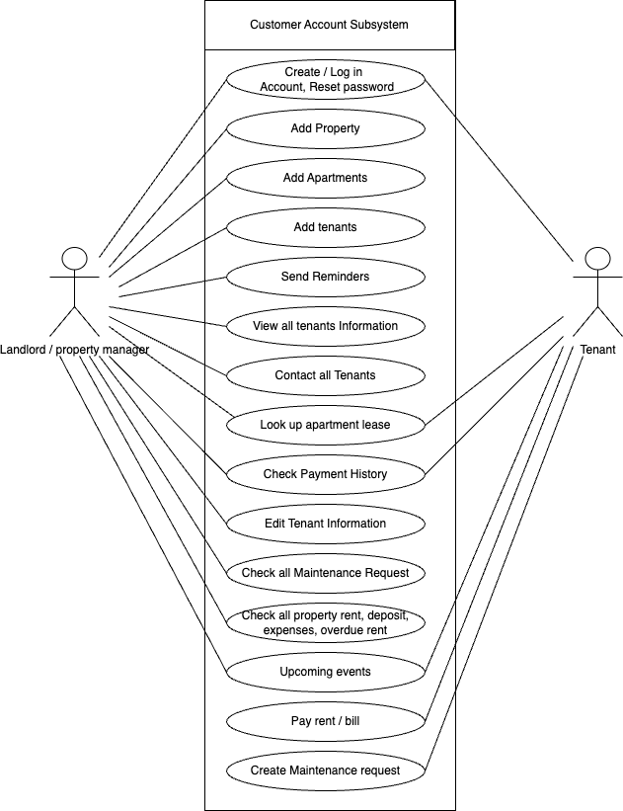

**CRUD Matrix**

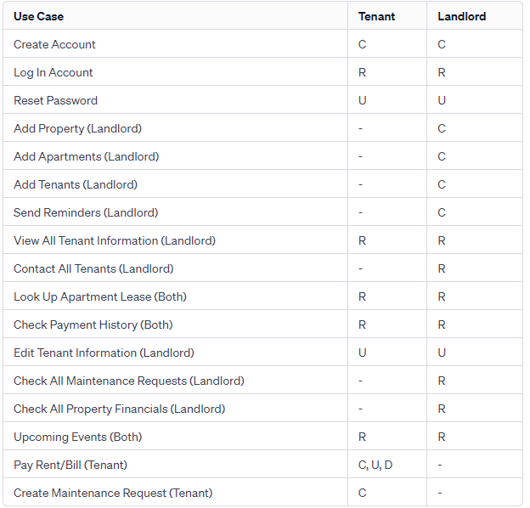

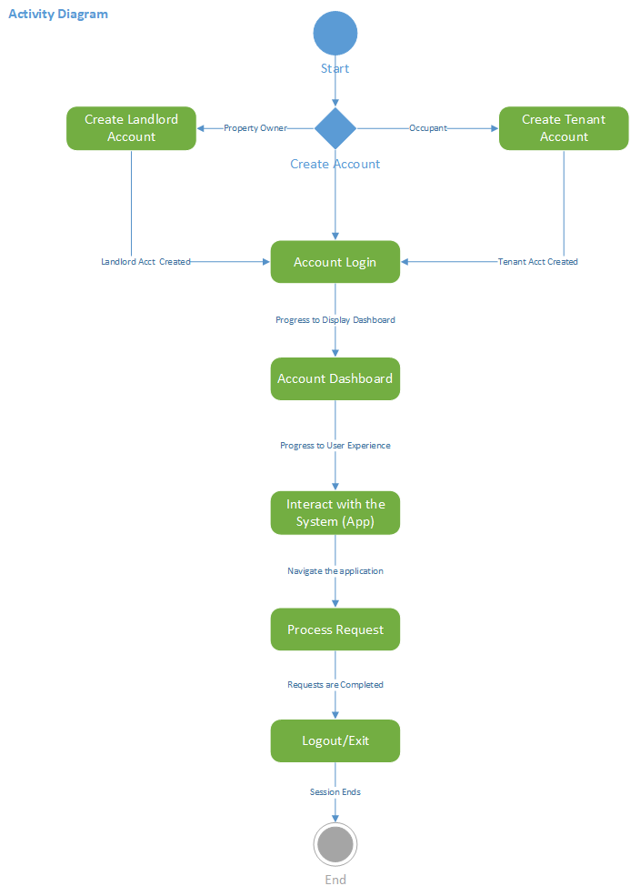

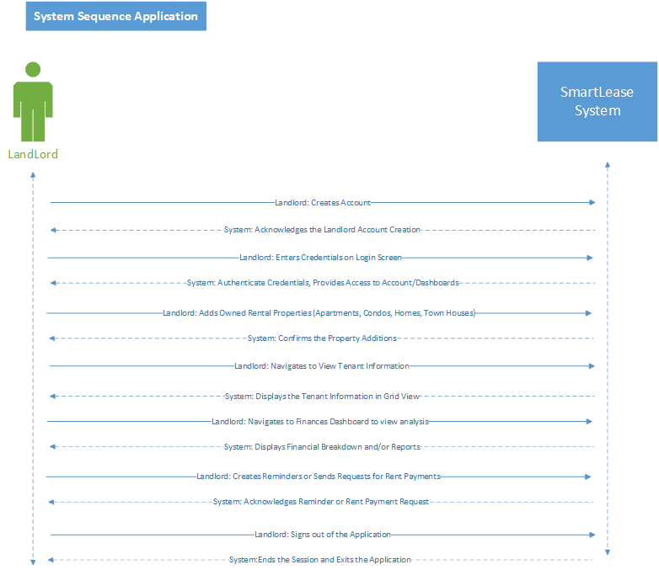

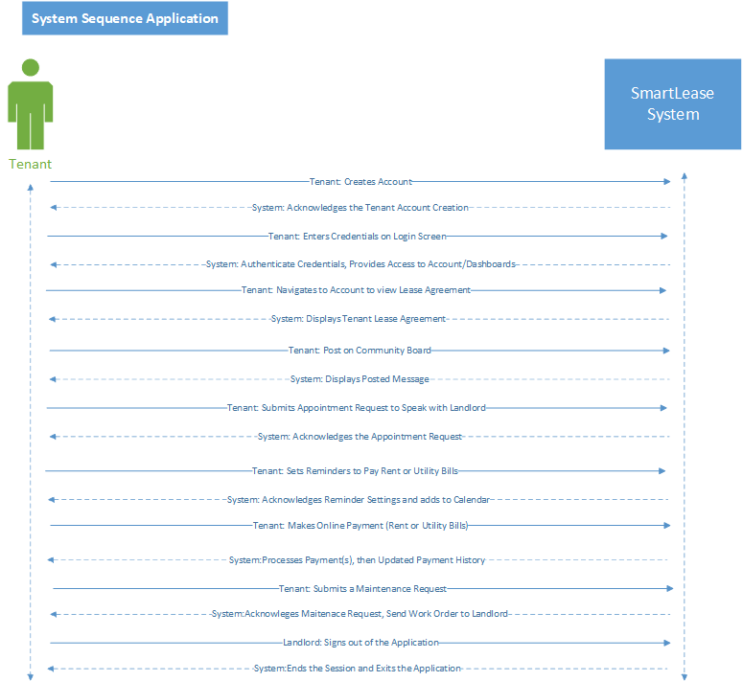

**Domain Model Class Diagram**

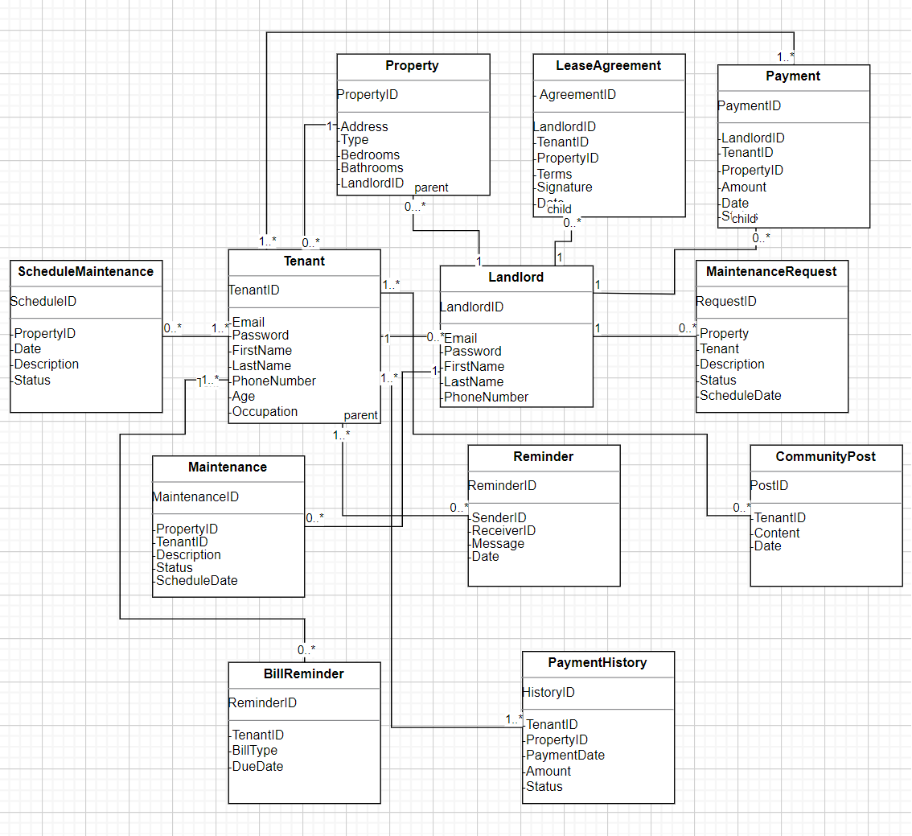

**Graphical User Interface (GUI)**

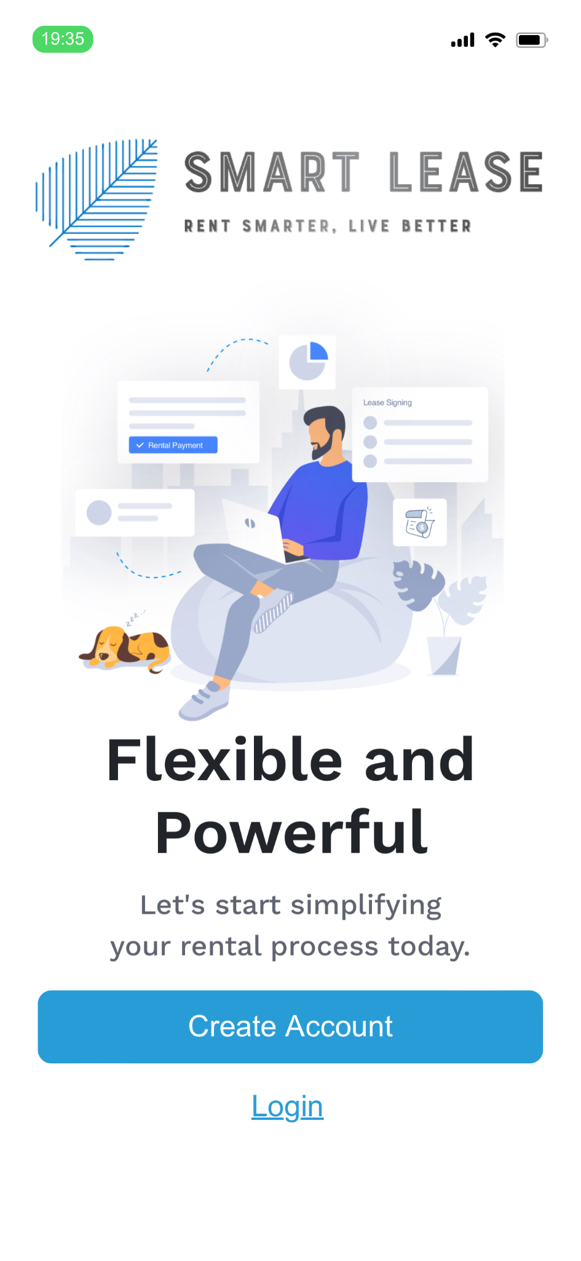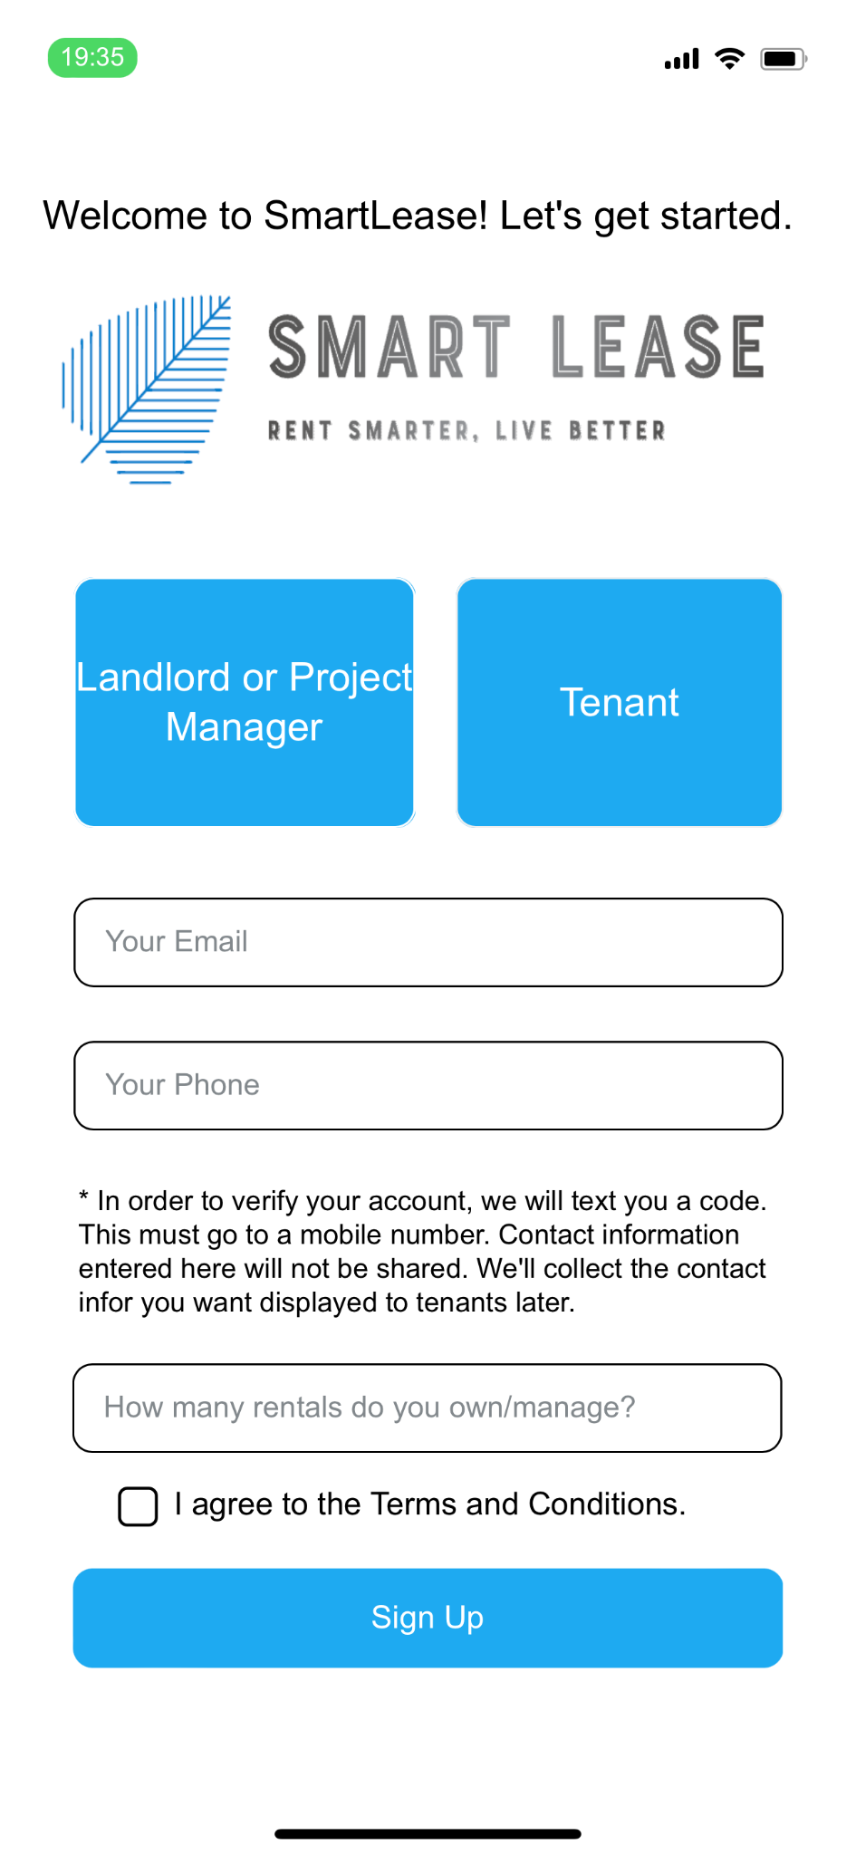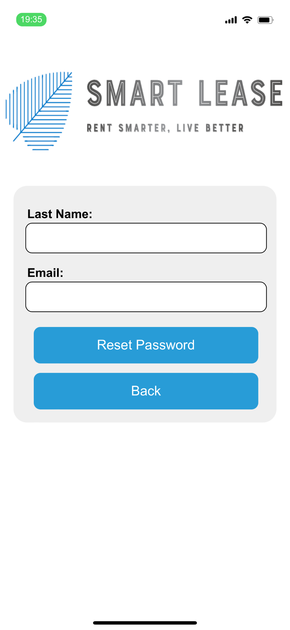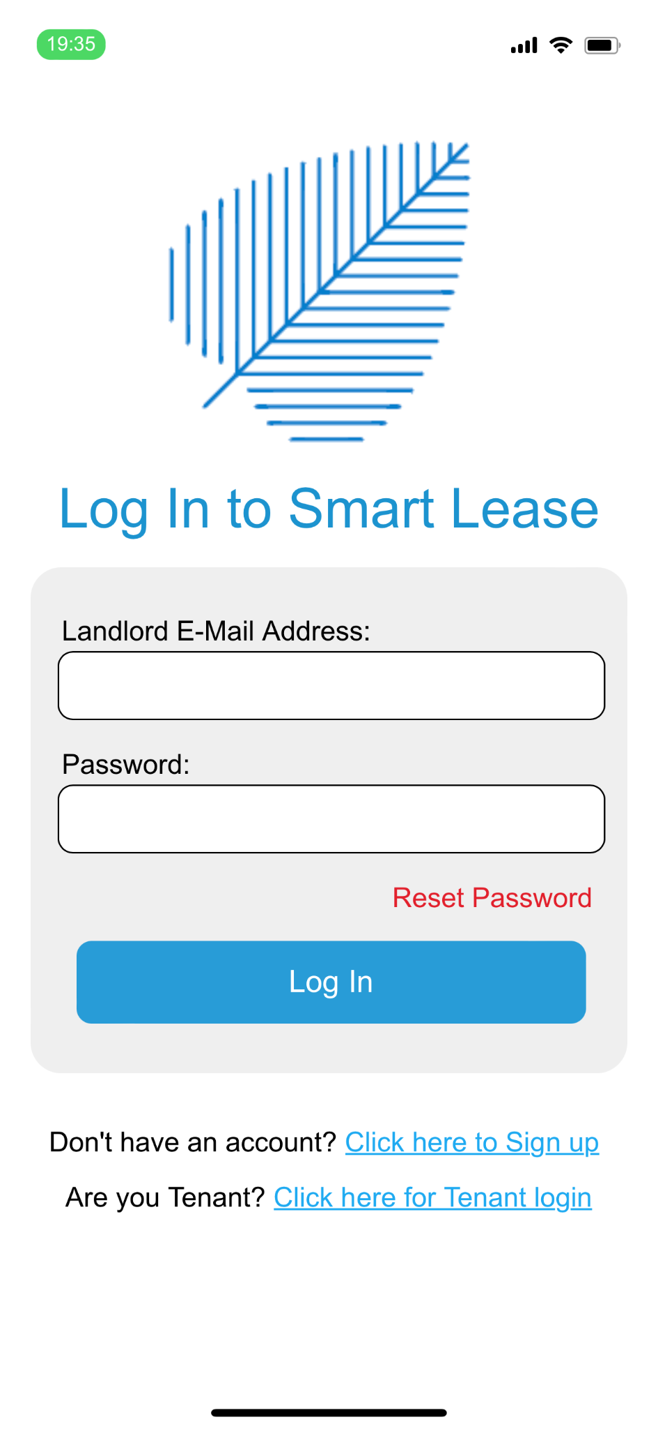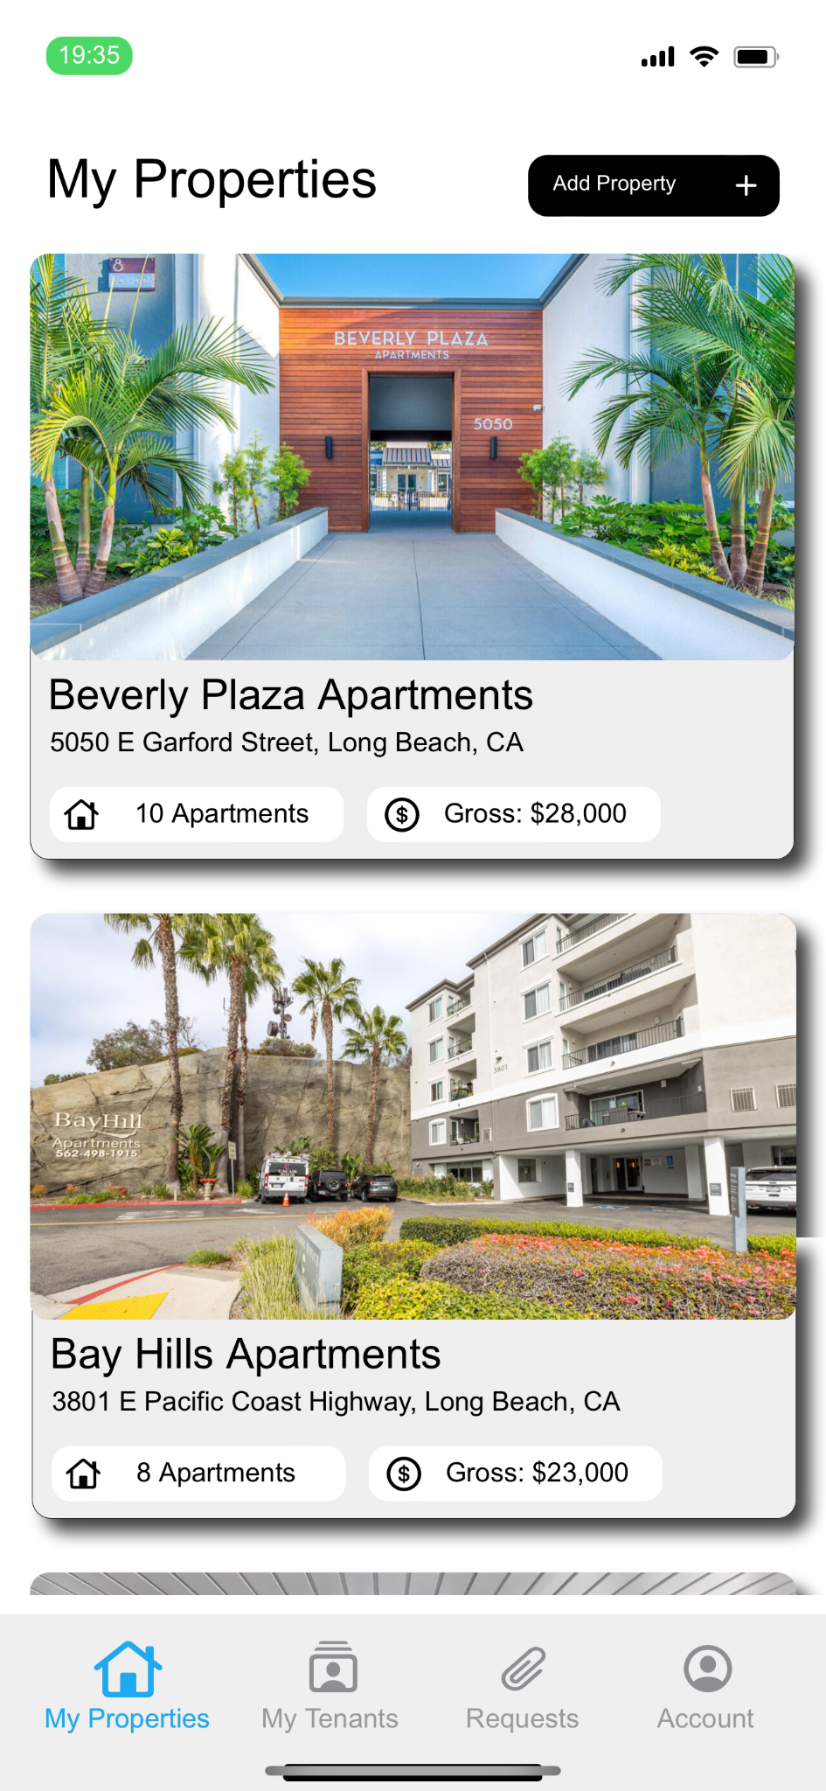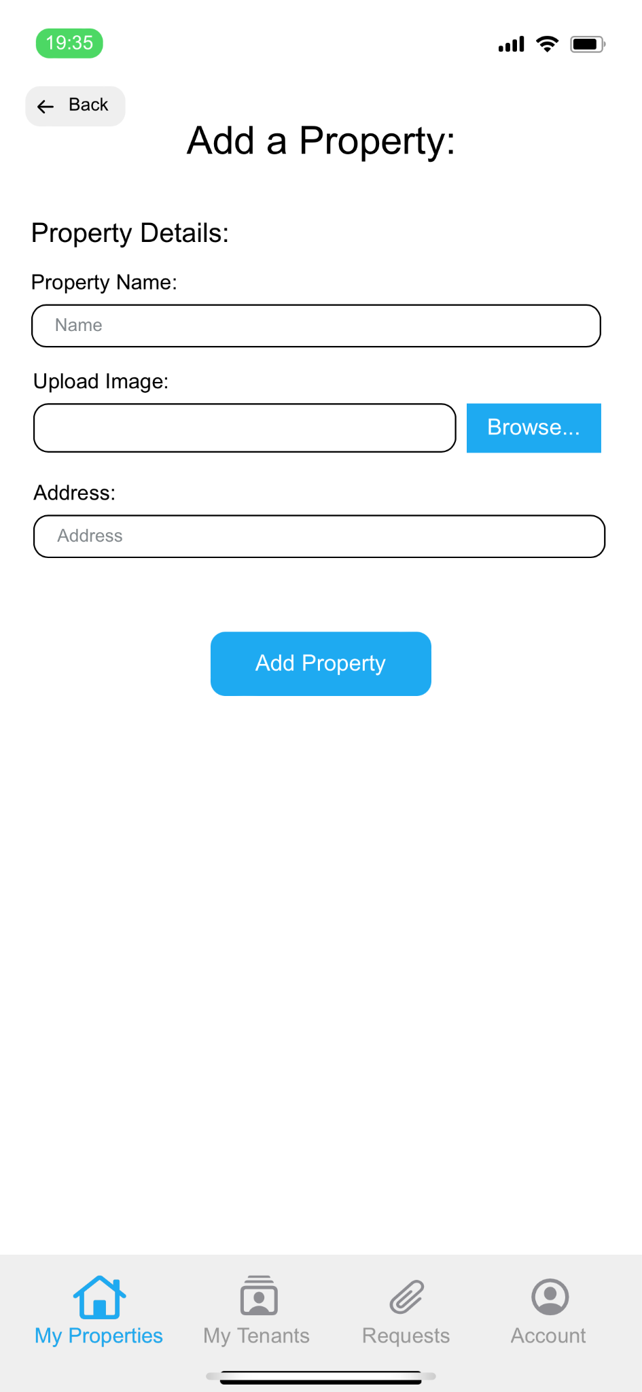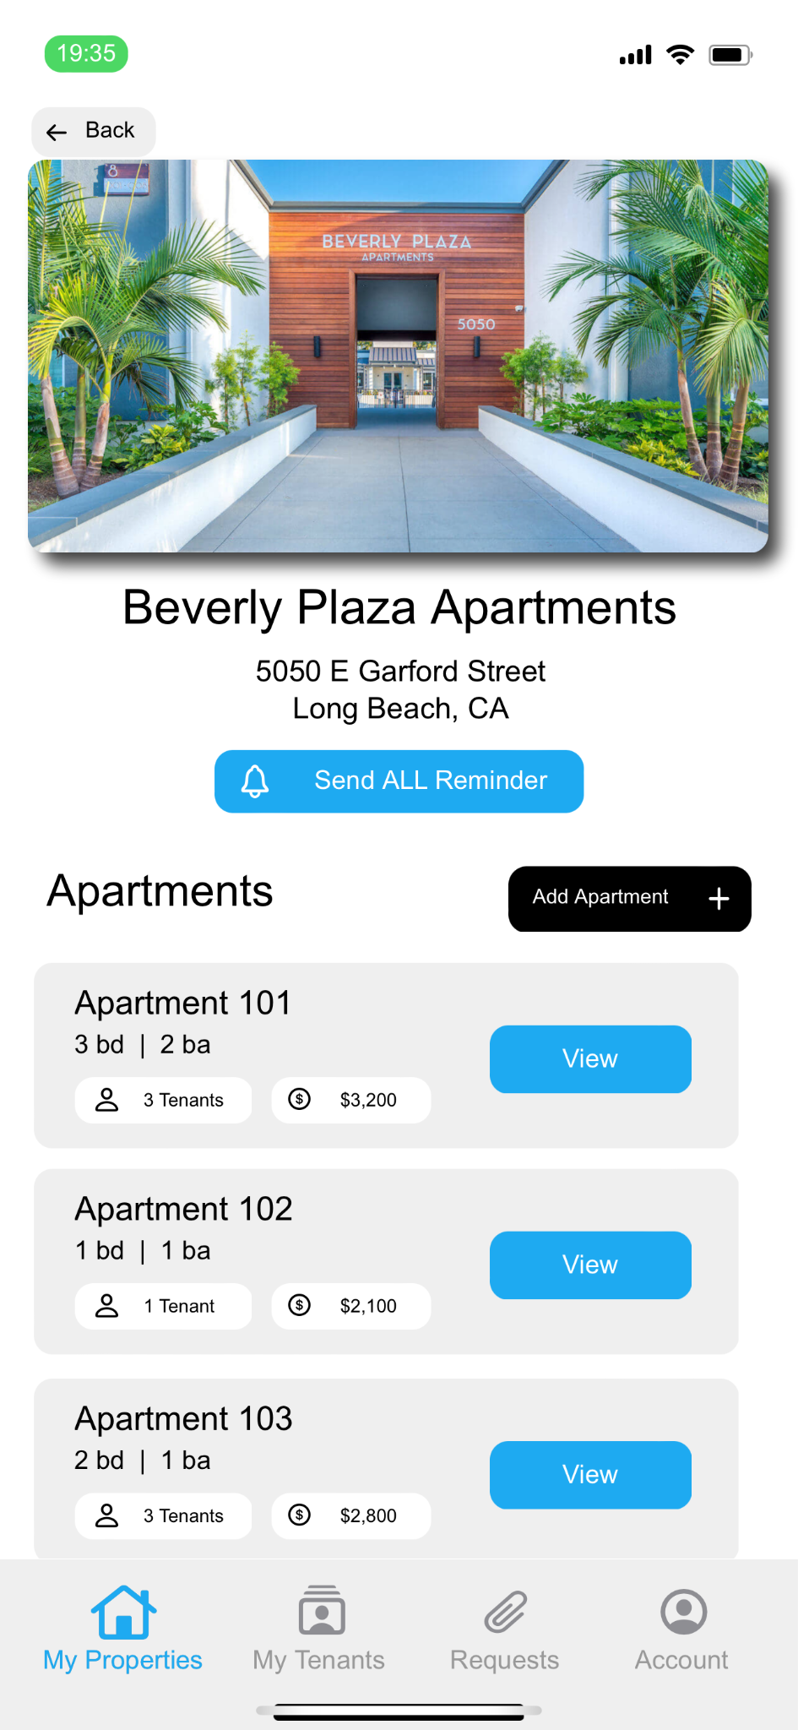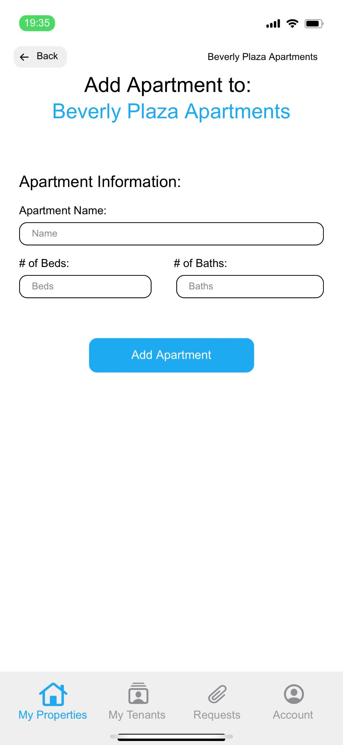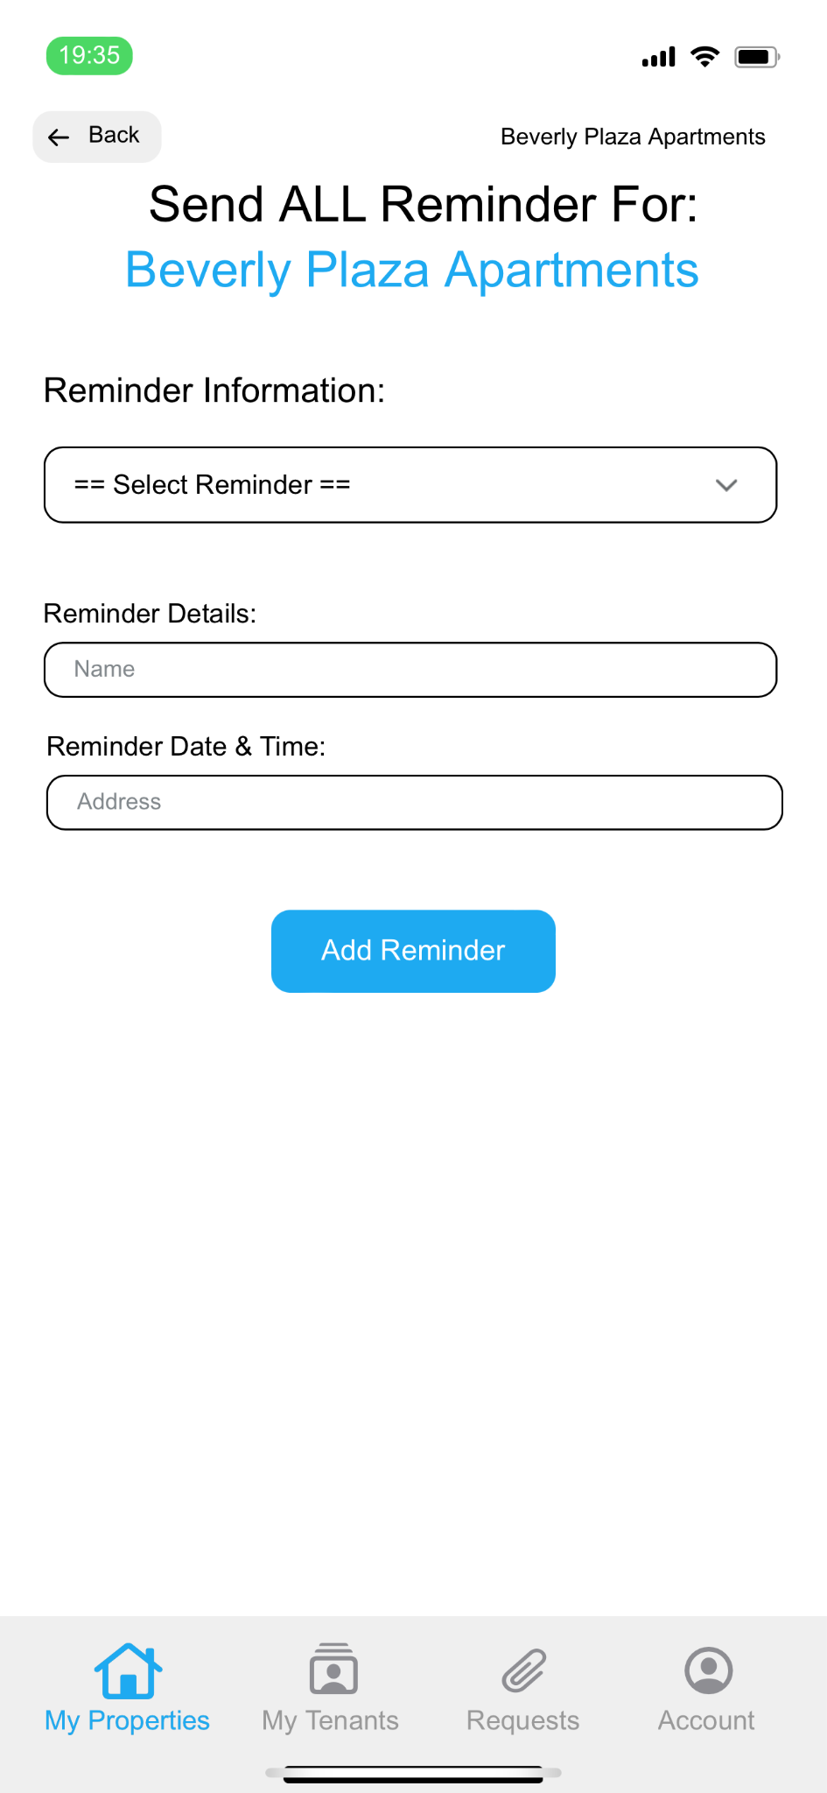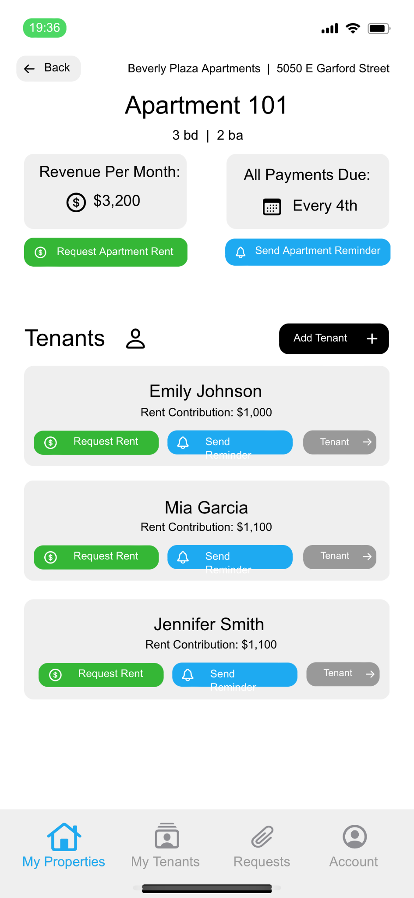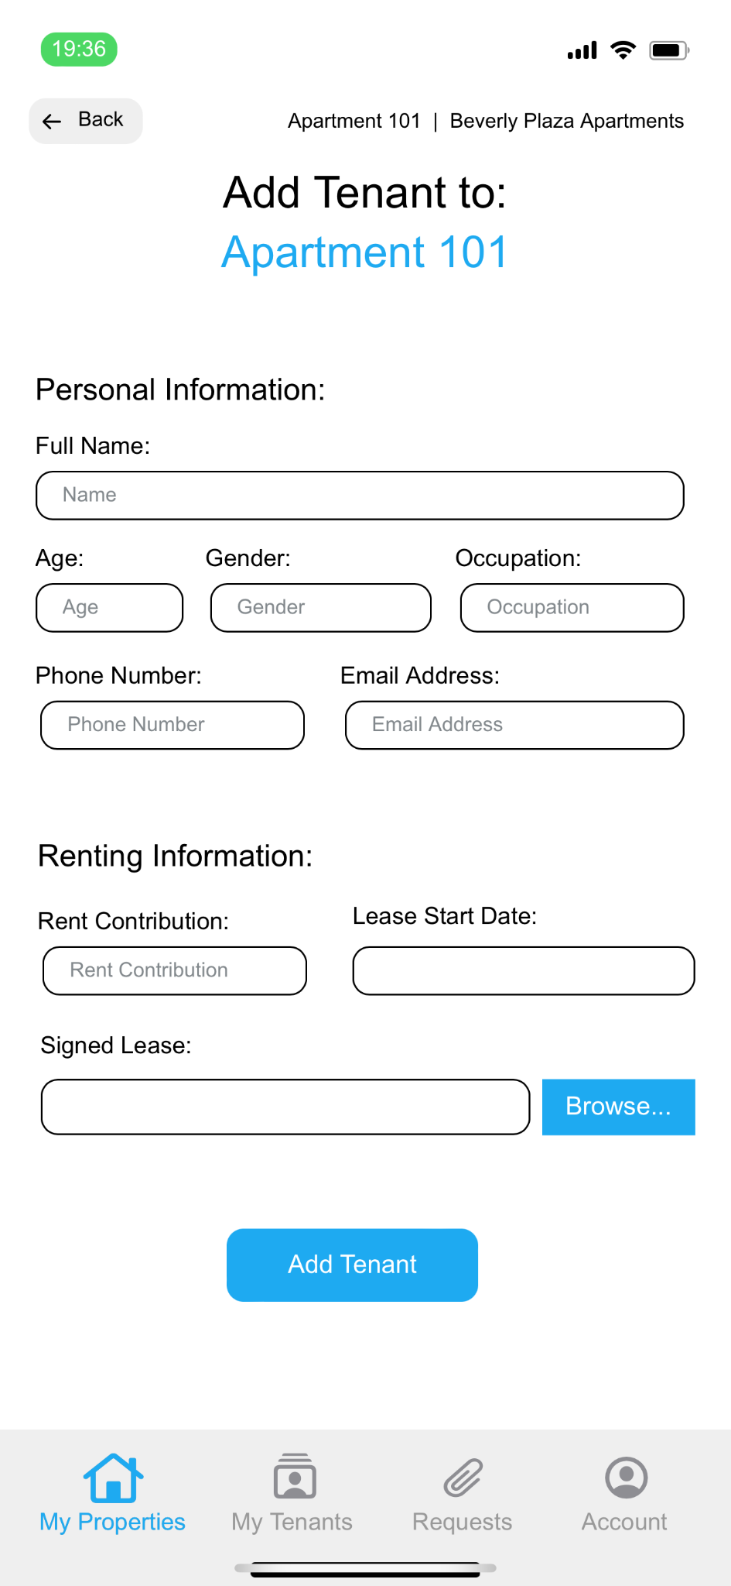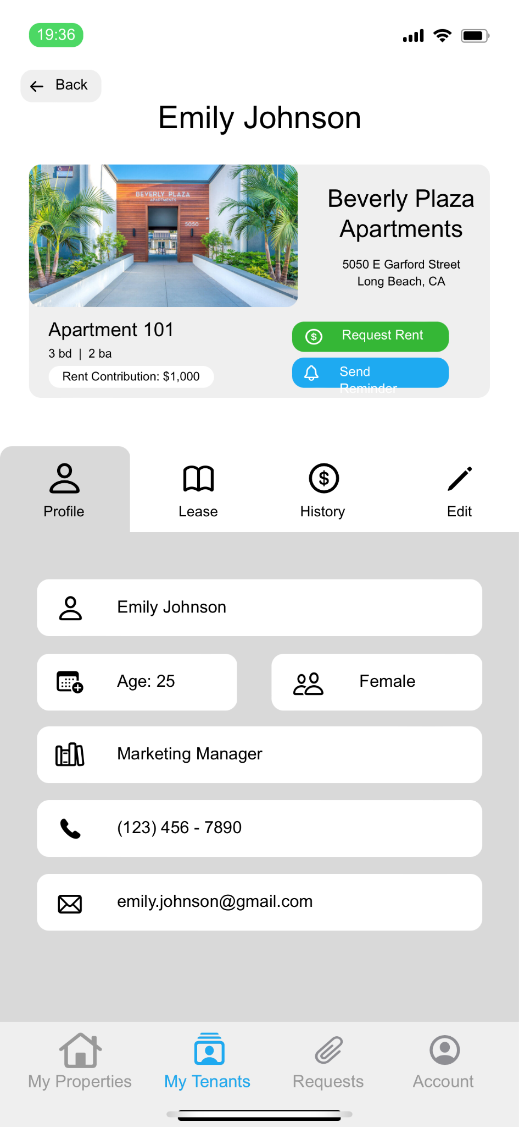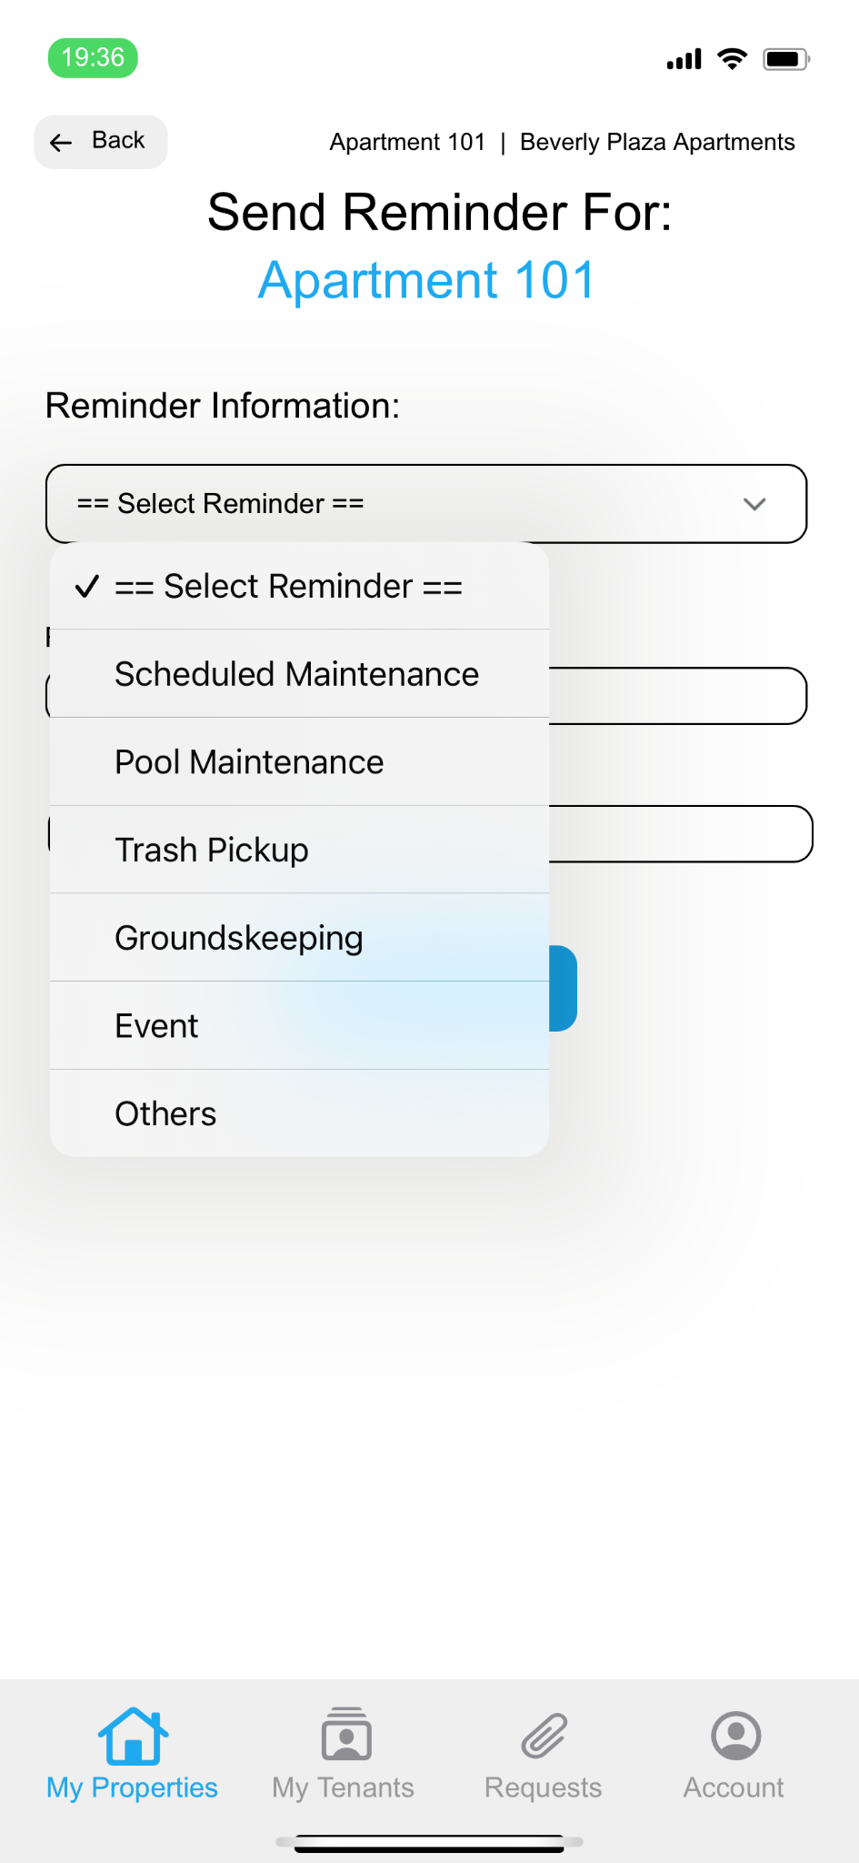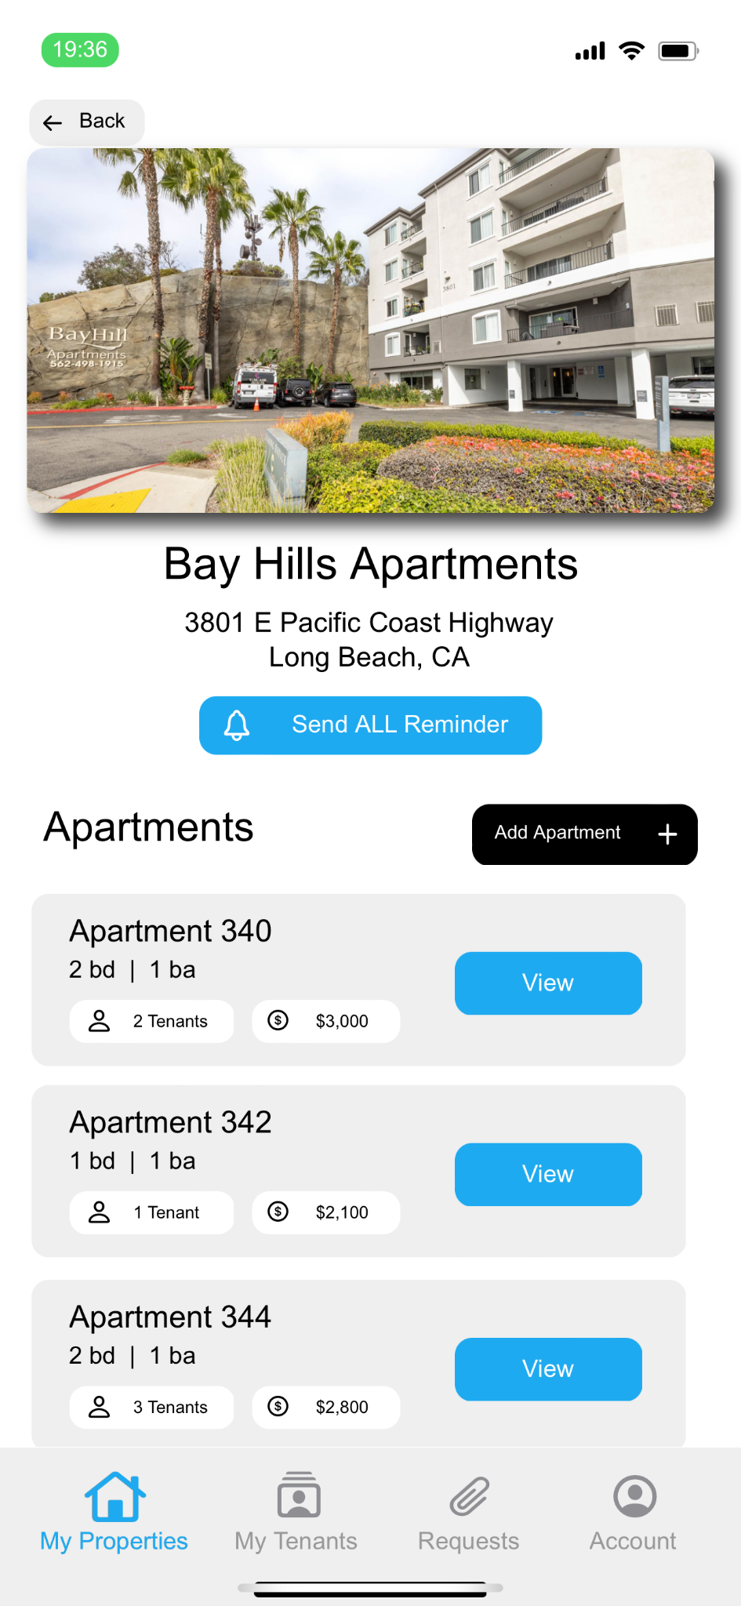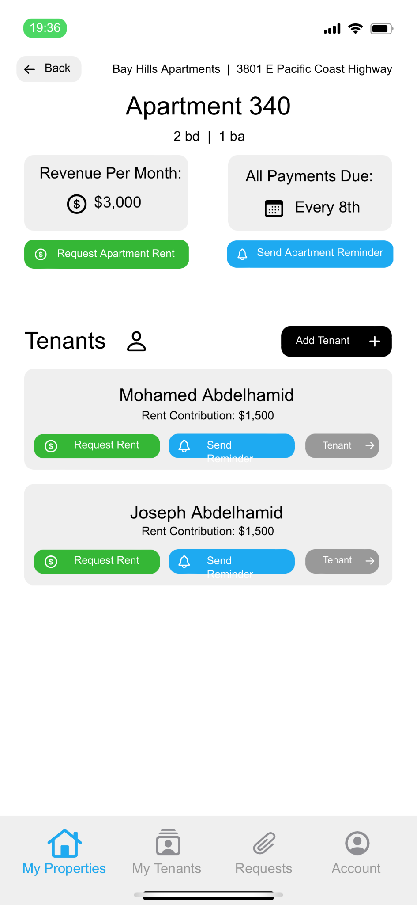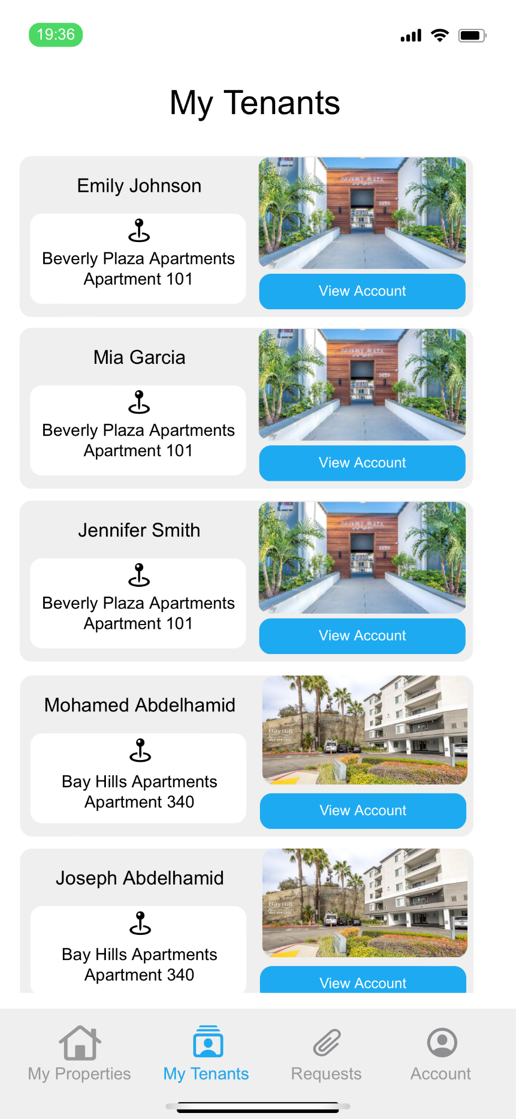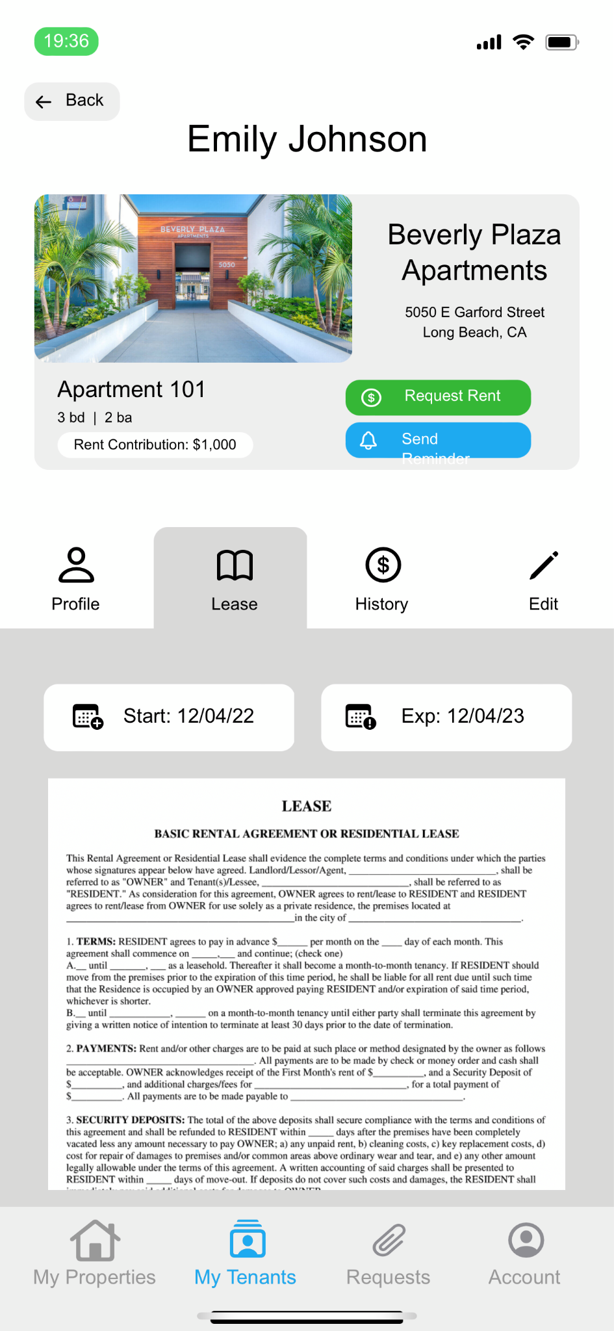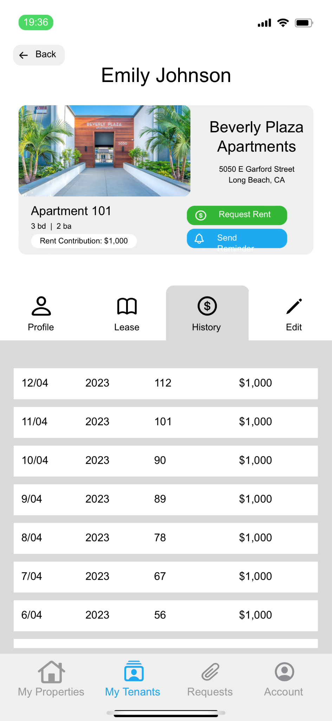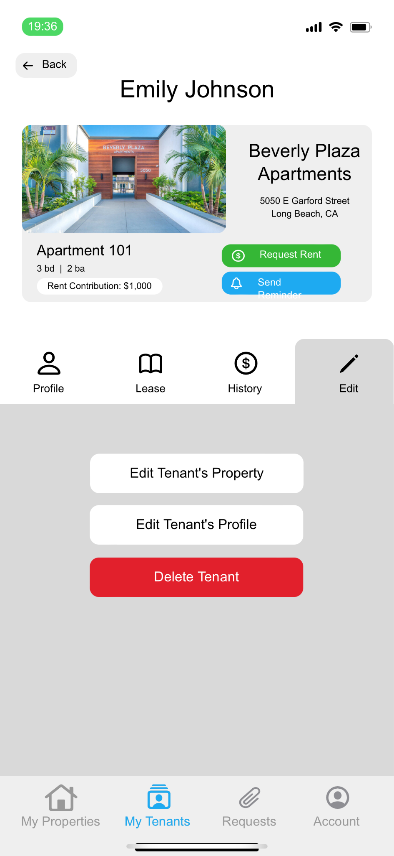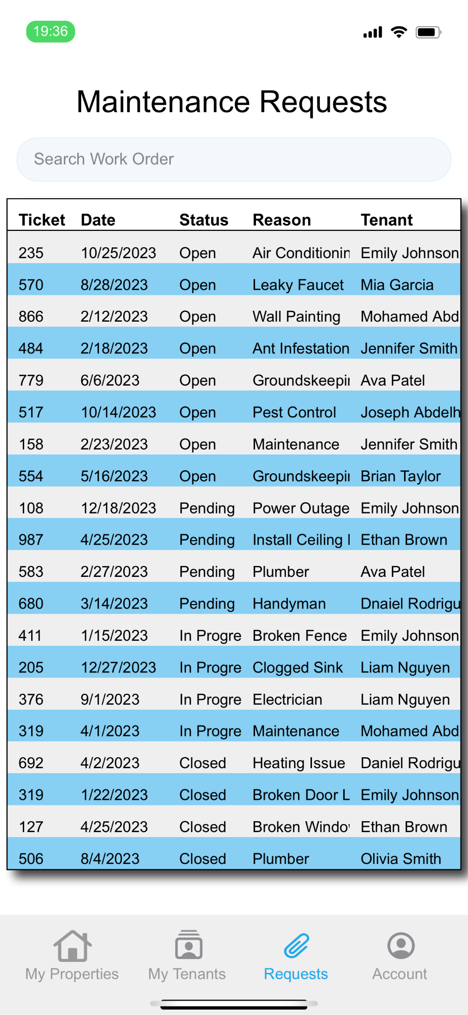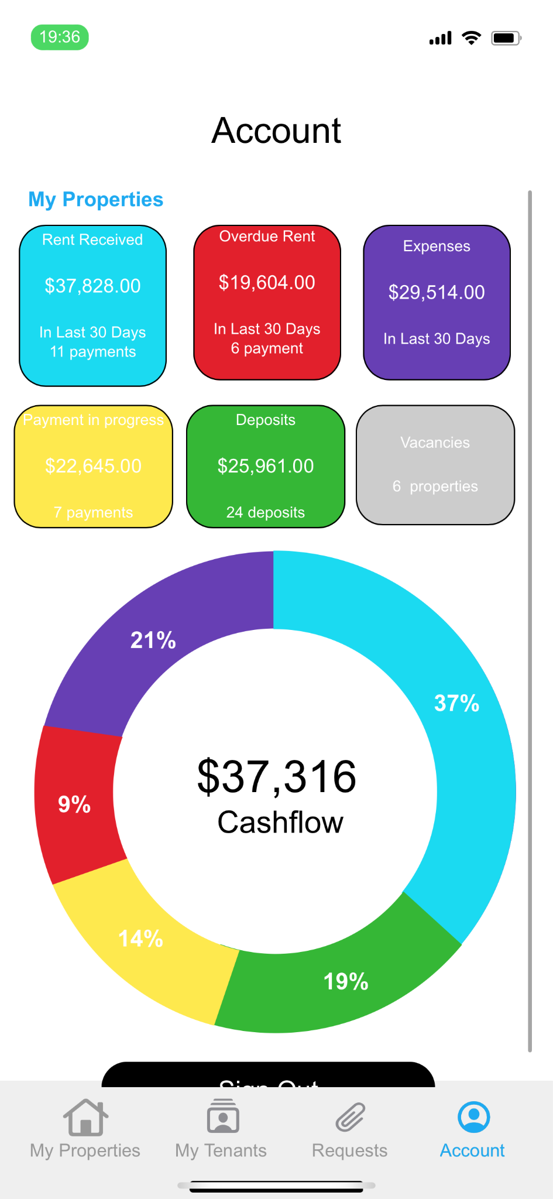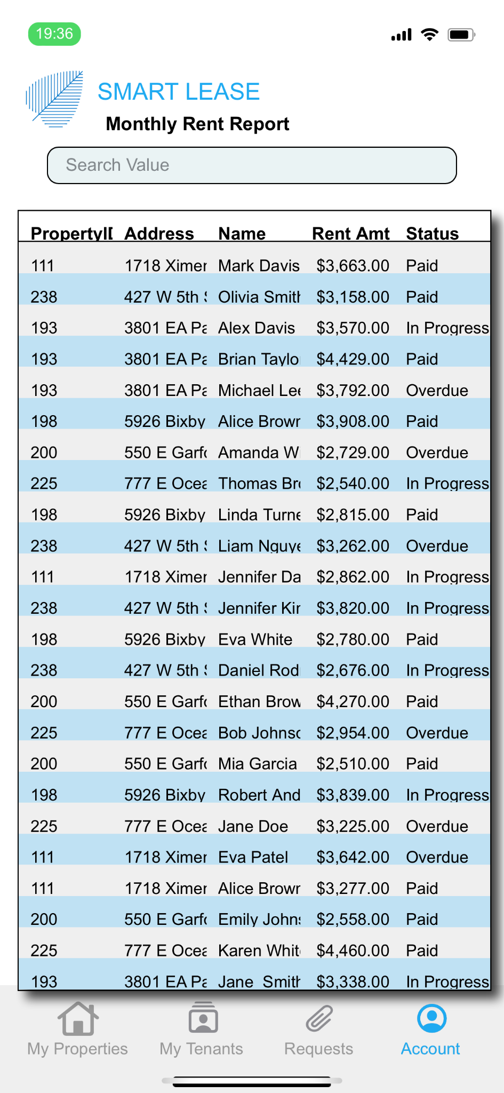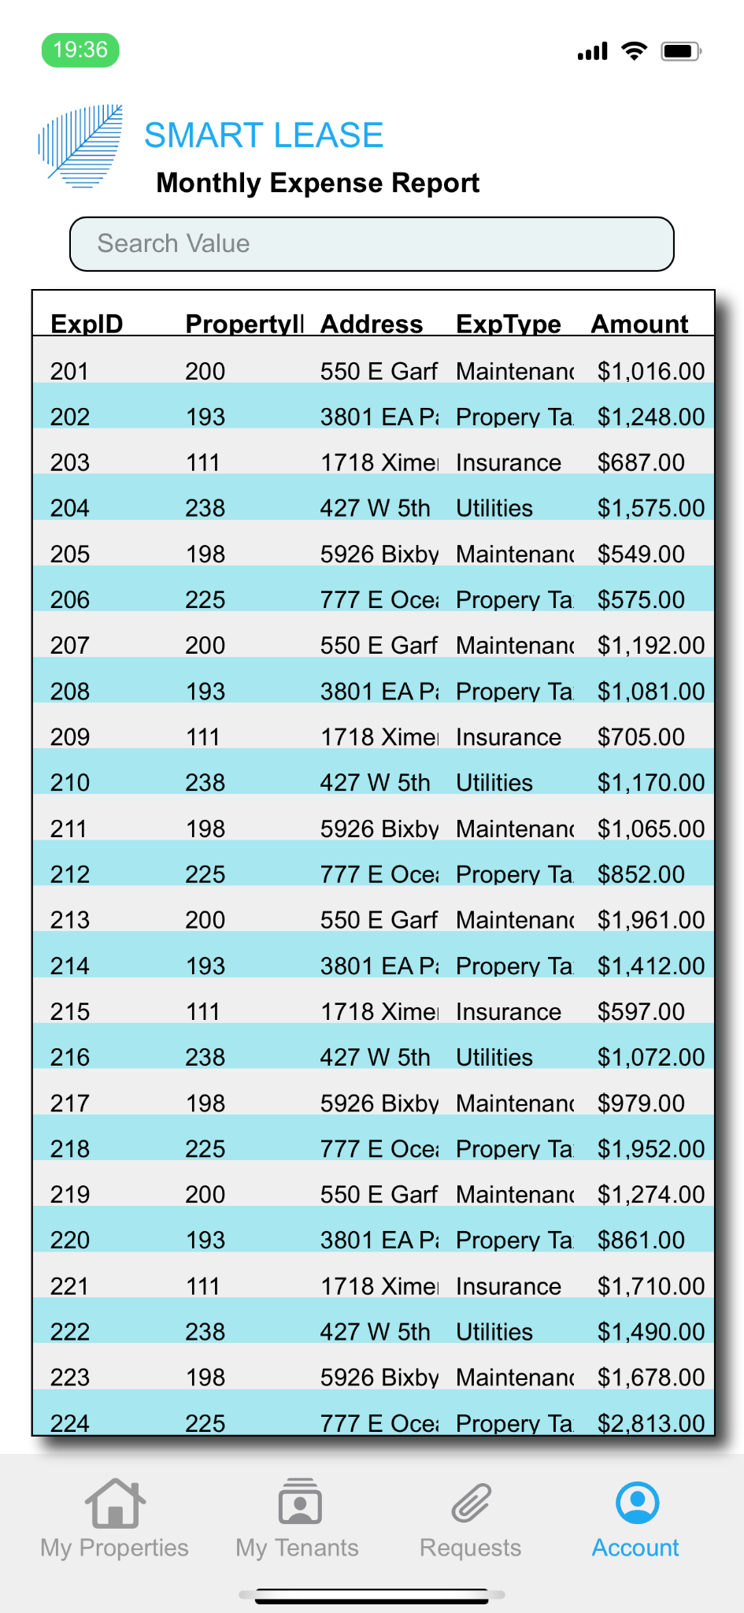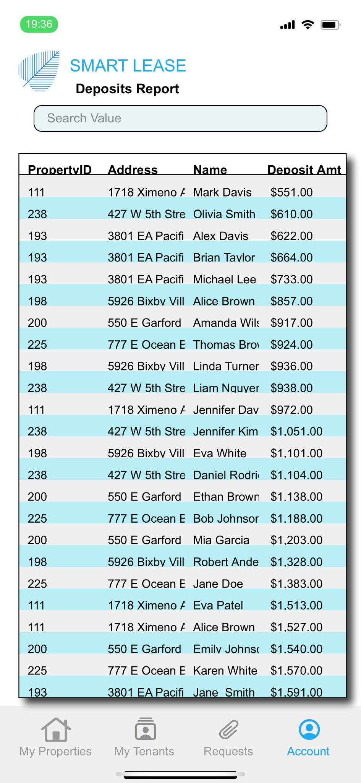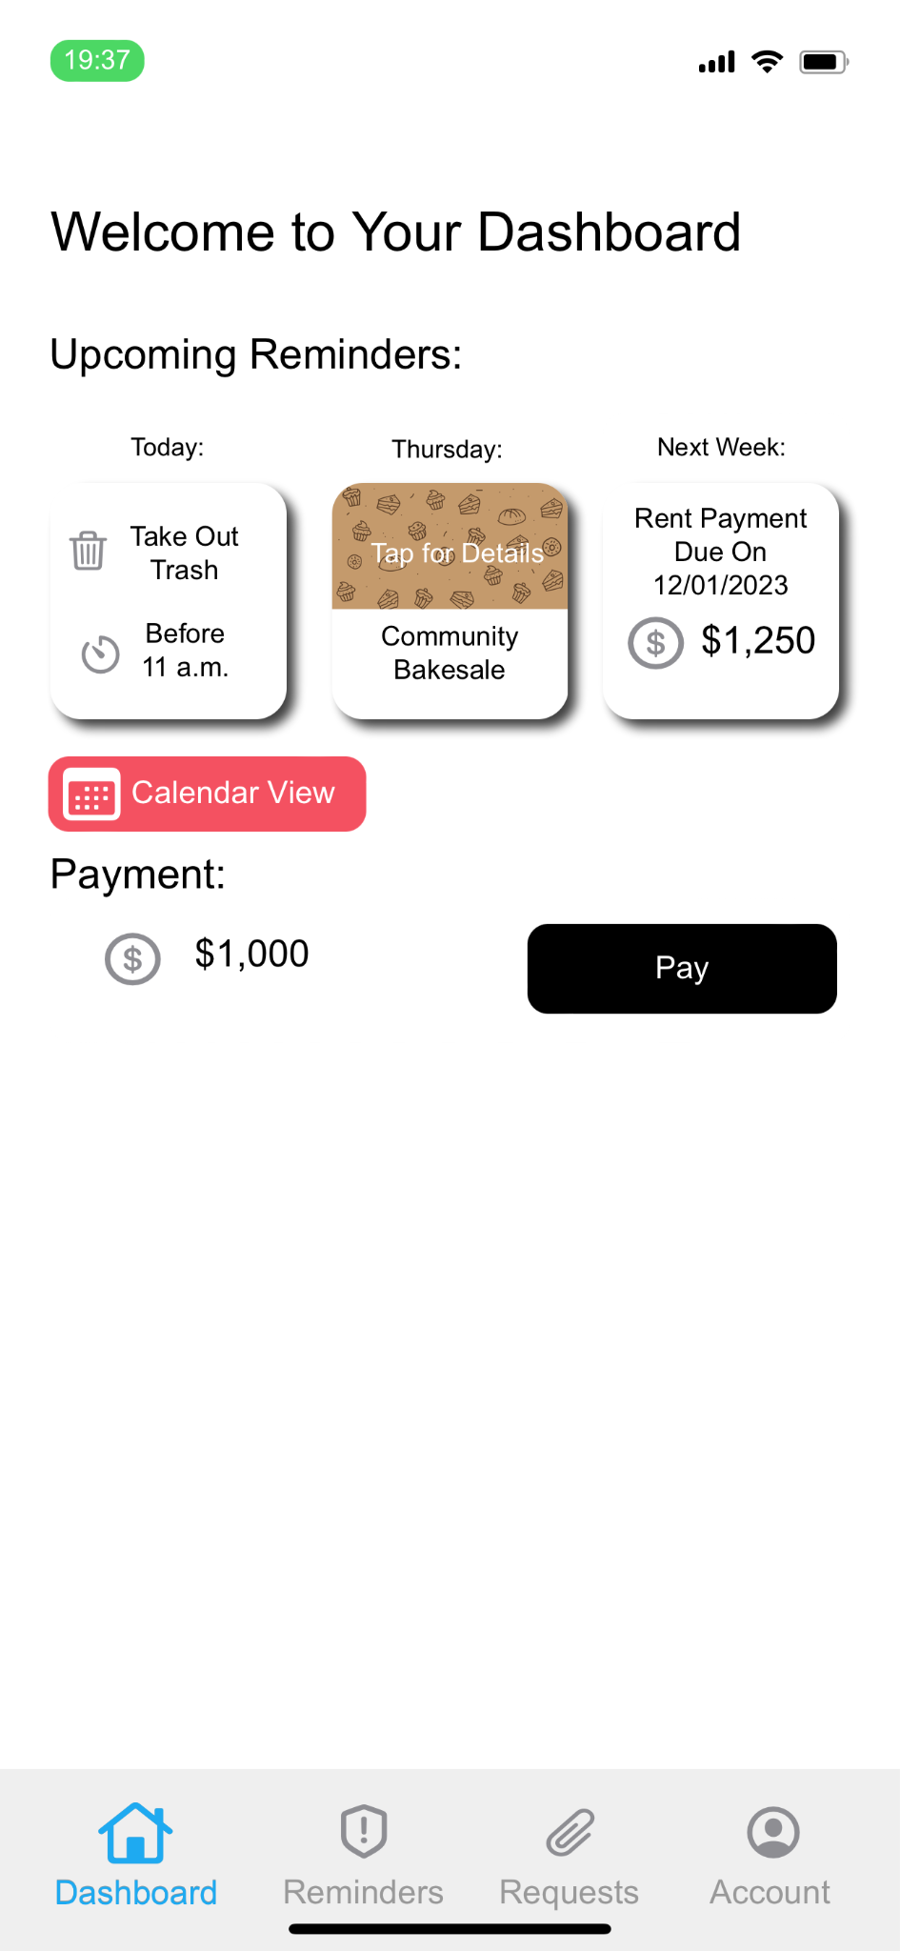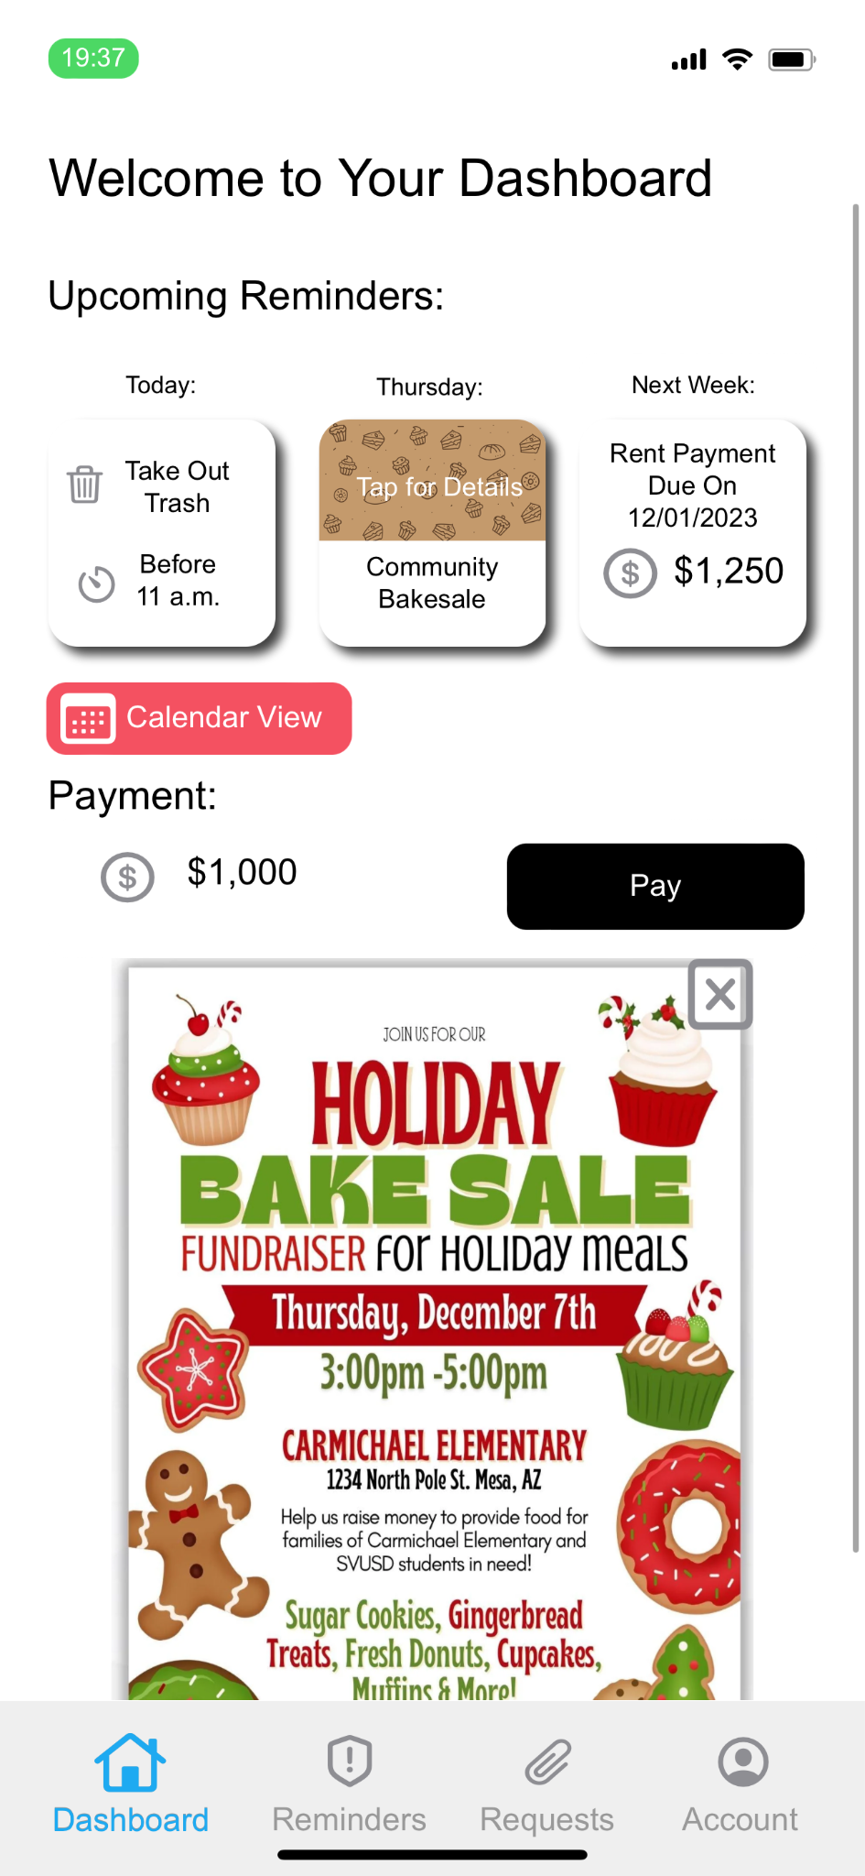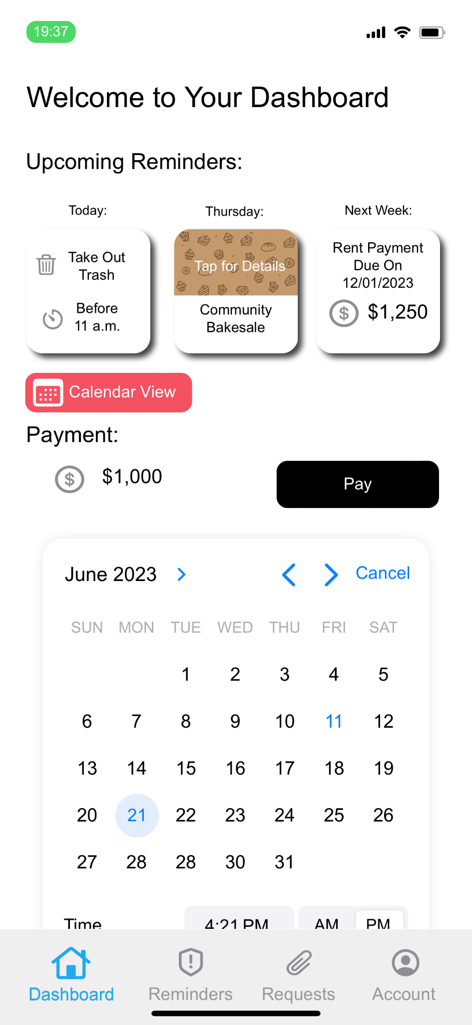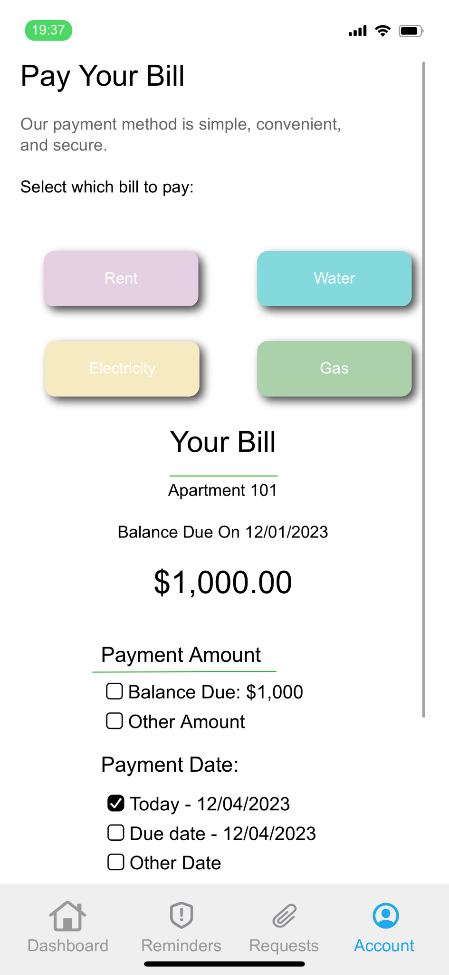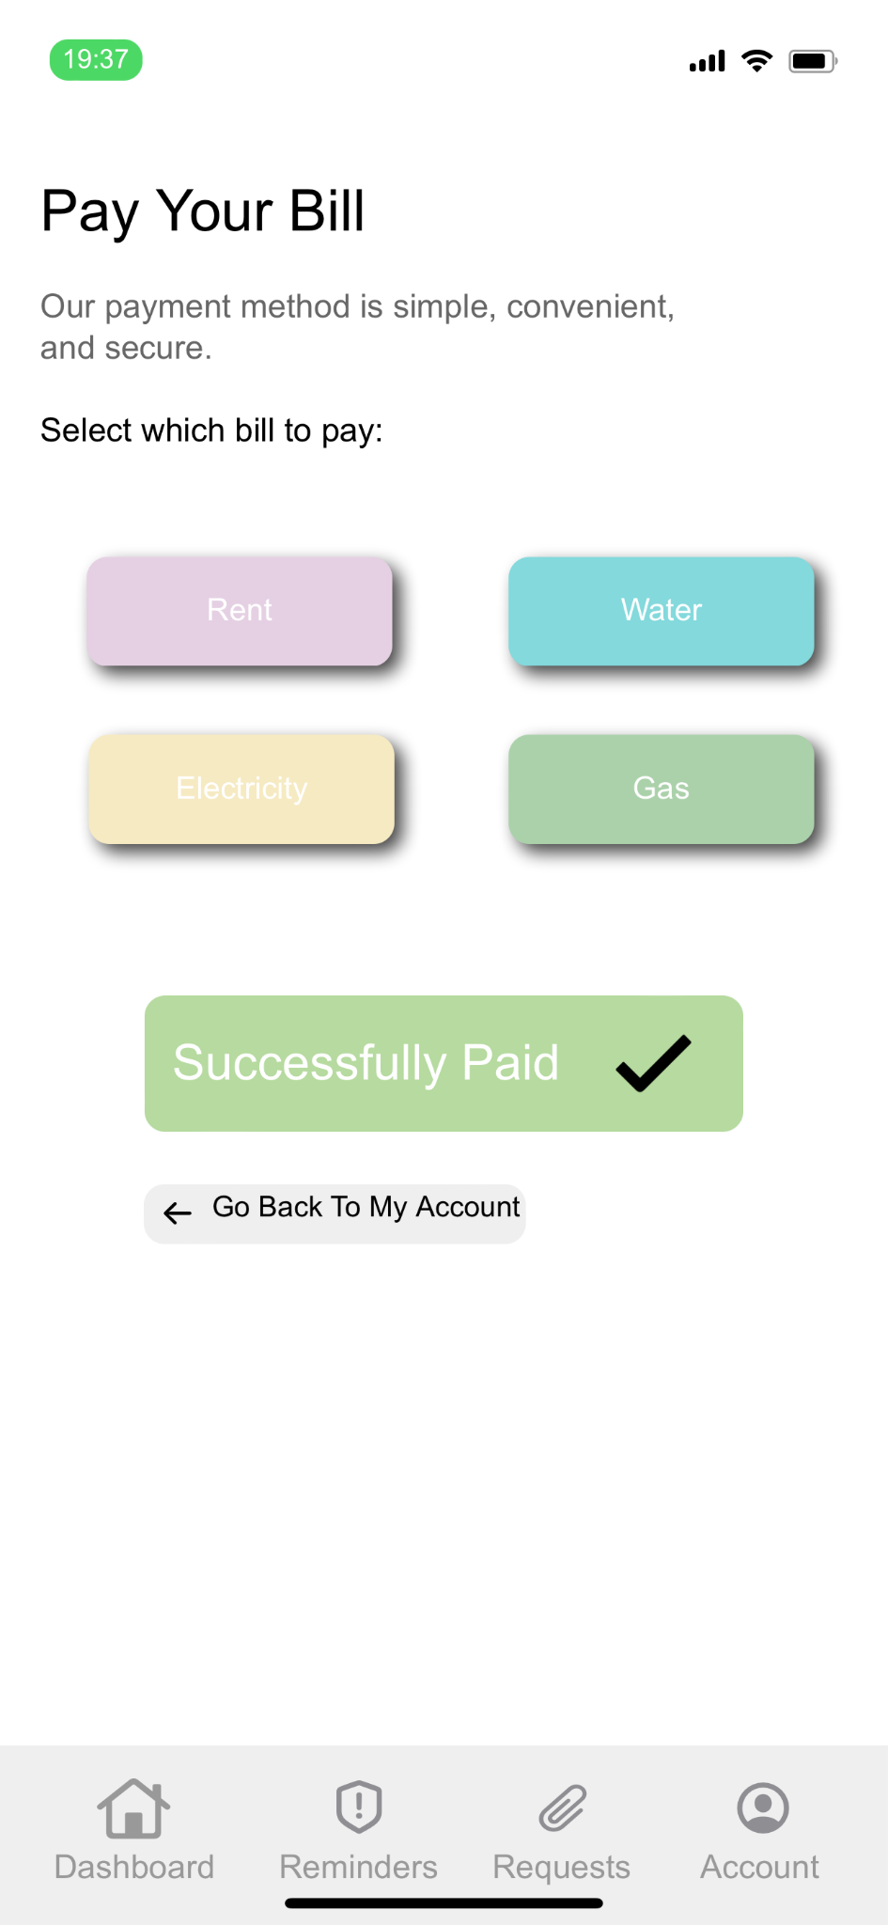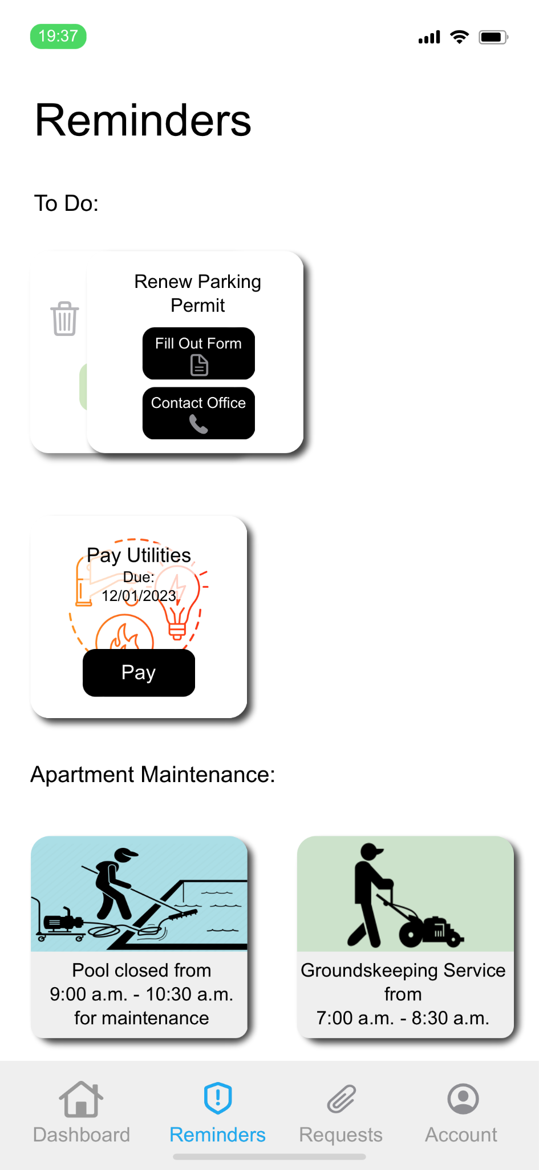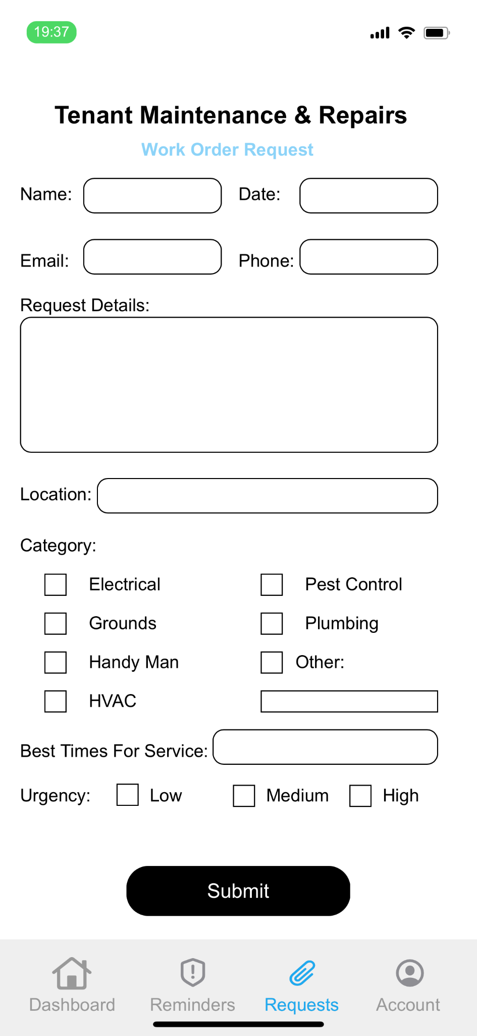

**Conclusion**

In the ever-evolving landscape of property leasing, SmartLease emerges as a transformative solution, addressing critical challenges landlords and property managers face. From the pressing need for centralized information to communication gaps with tenants and bottlenecks in handling maintenance requests, our comprehensive app has systematically alleviated these pain points, ushering in a new era of operational efficiency and heightened tenant satisfaction.

In realizing our vision, SmartLease goes beyond being a leasing app; it is a pioneering solution that redefines property management, setting a benchmark for excellence in the digital age.

Team: -

Nathan Nguyen

Keval Rakholiya

Aaron Morales

Rafael Melkumian

Liliana Rangel